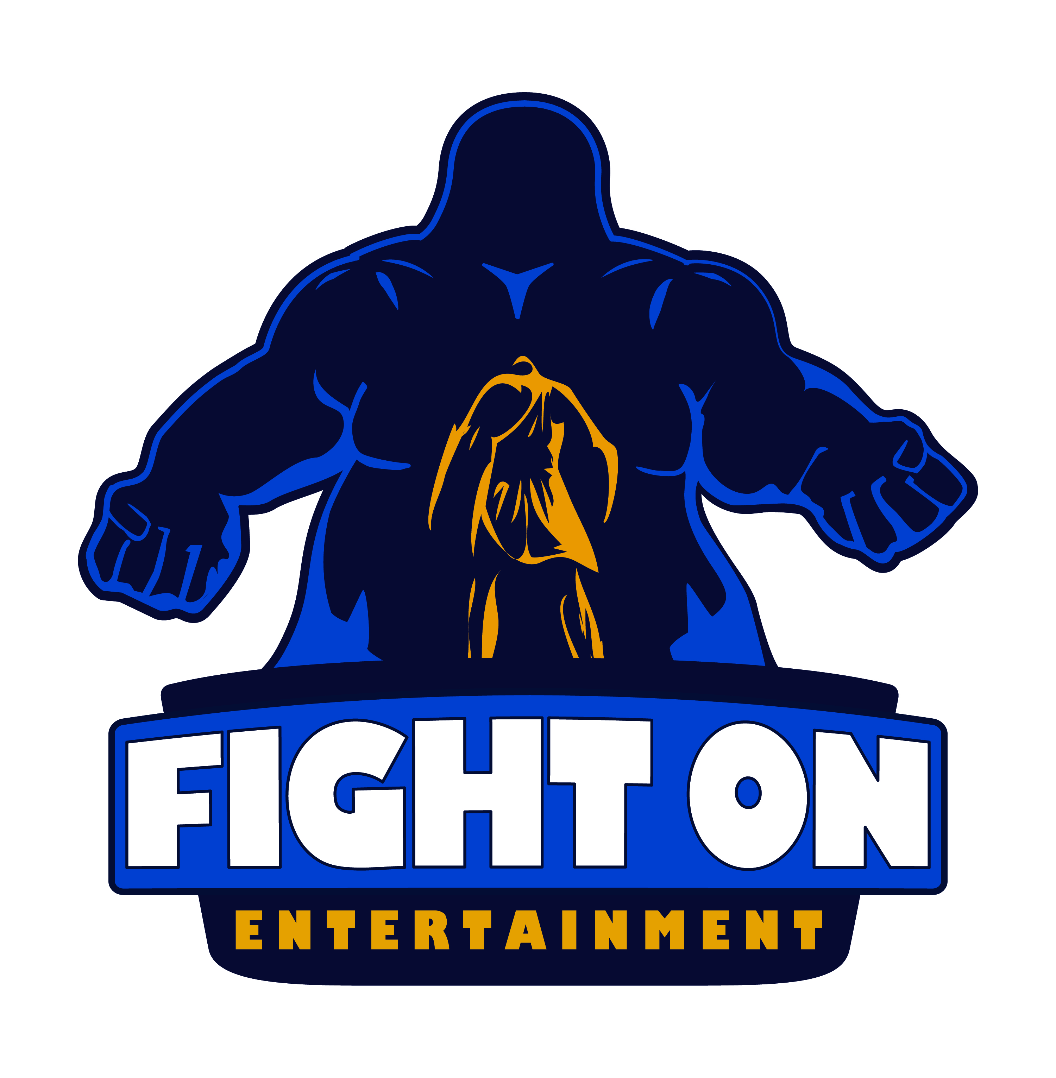**Jimmy Kelly**

President & CEO Fight On Entertainment LLC

1-631-291-5471

[jimmy@fightonentertainment.com](mailto:jimmy@fightonentertainment.com) & [fightonentertainment@gmail.com](mailto:fightonentertainment@gmail.com)

**Work Experience:**

1. Director, Writer, and Producer *IN CRITICAL CONDITION* (crime drama, feature, completed).
   * 1. WINNER: First Time Filmmaker, Los Angeles Independent Film Festival Awards May ’16. Supporting Actor Austin Frye, Asheville Film Festival ’16.
     2. Official Selection to NewFilmmakers NY ’17, Blow Up International Arthouse Film Fest Chicago, & Miami Independent Film Festival Nov. ’15.
     3. On sale now at Amazon, Walmart, Turner Classic Movies, and more.
        1. Sold out on Amazon within the first 24 hours of release (July 17th 2018)
     4. Distributor: Summer Hill Films.
     5. Rep: Circus Road Films.
2. Director, Writer, and Co-Producer for Gruenberg Kelly Della commercials.
   * 1. Feb ’16 to Present (Time Warner, Cablevision, FIOs, Online).
     2. Direct T.V. Campaign.
3. Director, Co-Writer, Co-Producer POLYBIUS (short, sci-fi, horror).
   * 1. Starring Tom Atkins.
     2. NYC Horror Film Fest. ’16 Award Winner for Best-Unproduced Screenplay.
     3. Shot in May 2018, currently in postproduction.
     4. Press: Long Island Advance, The Dan Romano Show.
4. Writer THE JOANS’ KILLER (animated short screenplay).
   * 1. Winner top ten at CINEQUEST ‘16, NYC Midnight 15’, NYC Independent Film Festival ’16, and HollyShorts ‘16. Semi-Finalist at Shorts on Tap ‘17.
5. President & CEO **Fight On Entertainment LLC**, an Indie Film Production Company. January 2013-Present.
   * 1. Producer & First AD:
        1. THREE DAY FILM SCHOOL (Director Glen McBride Jr.)
           1. January 2018.
           2. Completed
        2. THE CULT (Also co-writer) (Director Glen McBride Jr.)
           1. October 2018.
           2. In Preproduction
        3. HALF-ASS KILLERS (co-writer) (Director Glen McBride Jr.)
           1. T.B.A.
     2. *RETURN TO SOUTH HAVIN* (mockumentary, completed).
        1. Director, Co-Writer, Co-Producer, Director of Photography, Editor.
        2. Official Selection: 2018 Manchester Lift-Off Film Festival, LA Shorts Awards ‘18, One-Reeler Short Film Competition ‘18, & Miami Independent Film Festival ‘18.
     3. Projects in development include:
        1. *SURVIVE* (Zombie, Feature). Semifinalist 4th New Blood Contest as well as Finalist at Film Invasion LA, Oaxaca, and Los Angles Horror Film Awards. Director, Writer, Producer.
        2. UBER SCARY (Thriller, Short). Director, Writer, Co-Producer.
        3. GRAVEYARD SHIFT (Comedy, Short) Co-Writer, Producer.
     4. Script Consulting as Script Doctor Kelly, 2014 to Present.
     5. Guest author for Filmmaking Stuff Blog (by Jason Brubaker).
        1. 7 Essential Documents Every Filmmaker Needs.
        2. 5 Reasons to Submit your Screenplay to Film Festivals (release tbd).
     6. Outreach work with ArtSpace OF COLORS and Kiwanis Club Patchogue.
     7. Panelist at NYC Independent Film Festival May, 2017.
        1. Surviving as a Filmmaker Panel.

**Education:**

1. BFA Filmmaking from UNCSA School of Filmmaking (2009 - 2013).

**Director** – *U666, Kings and Queens, The King Of Spades, Last Night Home.*

**Writer** – *The King of Spades.*

**Producer** – *Craven, Your Butt Was In My Face Last Night, Last Night Home.*

**2nd Assistant Director**– *Off Broadway The Musical.*

**Grip** – *Bells of Frankenberg, And the Rest Writes Itself, Black Canvas, The Gravy Farmer’s Curse, NC – 14* (Best Boy).

**Set Dresser** – *Parts, U666, Bells of Frankenberg, The Road Home.*

**Script Supervisor –** *Under Street Lights From A Distance.*

**Classes** - in **Directing** (4 years), **Screenwriting** (2 ½ years), Editing, Producing, Cinematography and Production Design (All 1 year).

1. Dov Simen’s 2-Day Film School, July 16th + July 17th 2012 NYC.

**Lecture topics** included how to make a feature with no budget, and how to get distribution.